**Aim:** Exploring the basic functionality of excel

**IDE:** Microsoft Excel 2013

**Questions:**

1. **Average "total cost" and count of the product 1 under small order category**

* Select Filter Option
* Filter the Product_# column for product 1 and Filter Order_Categeory to small order.
* Now Select the Total cost for fitered output and get the count and average from bottom right corner.
* **Answer :-** Count – 11

Average Total Cost = $50.73

1. **Average "total cost" and count of the product 1 under normal order category**

* Select Filter Option
* Filter the Product_# column for product 1 and Filter Order_Categeory to normal order.
* Now Select the Total cost for fitered output and get the count and average from bottom right corner.
* **Answer :-** Count – 14

Average Total Cost = $151.71

1. **Average "total cost" and count of the product 1 under large order category**

* Select Filter Option
* Filter the Product_# column for product 1 and Filter Order_Categeory to large order.
* Now Select the Total cost for fitered output and get the count and average from bottom right corner.
* **Answer :-** Count – 32

Average Total Cost = $402.75

1. **Which month is having the highest count of orders placed?**

* Insert New Colum named month.
* Insert formula **=MONTH(G2)** where G2 is the cell where date of that order is written. Drop down the formula till last row.
* Now in one new column write 1 to 12 one by one in rows.if your 1 to 12 is written in O2 to O13 then in one new column insert formula **=COUNTIF($H$2:$H$501,O2),**  then you will get the count of each month. Then insert a fomula in new cell **=INDEX(O2:O13,MATCH(MAX(P2:P13),P2:P13,0)).** You will get your month having highest count of orders
* **Answer :-** November – 11

1. **Which year has the highest "average total cost"?**

* Insert New Colum named Year.
* Insert formula **=YEAR(G2)** where G2 is the cell where date of that order is written. Drop down the formula till last row.
* Now in one new column write 2010 to 2015 one by one in rows. if your 2010 to 2015 is written in R2 to R7 then in one new column insert formula **=AVERAGEIF($I$2:$I$501, R2, $M$2:$M$501)** then drag it till R7. You will get the Average of total cost for all years
* **Answer :-** Year 2011. Average Total Cost :- $152.7403

1. **What is the ratio of the number of orders placed by male and female ?**

* Insert a Formula in a new cell =**(COUNTIF($D$2:$D$501,"Male")/COUNTIF($D$2:$D$501,"Female"))**
* **Answer :-** Male = 219 , Female = 281 , Ratio = 0.77935943

1. **What is the ratio of the total cost of the orders placed by male and female ?**

* Insert a Formula in a new cell **=(SUMIF(D2:D501,"Male",M2:M501) / SUMIF(D2:D501,"Female",M2:M501))**
* **Answer :-** Male = $33603 , Female = $37441 , Ratio = 0.89749205

1. **How many orders are placed under each order category for the country "INDIA" ?**

* Select Filter Option. Select “INDIA” from Country Column and Select one by one category from Order_Category and count the number of orders after applying filter.
* **Answer :-** Small – 5 , Normal – 5 ,Large – 11

1. **What is the total cost of order placed by the customer "Willis Brinks"**

* Select Filter Option. Filter the Name Column and Select the Name as "Willis Brinks" and Select the column total cost after applying filter. And You will get the Total Sum in the bottom right corner.
* **Answer :-** $1214.00

1. **Name the customer who has placed the order having the highest amount.**

* Insert A Formula in a new cell **=INDEX(C2:C501, MATCH(MAX(M2:M501), M2:M501, 0))**
* **Answer :-** Britni Baisden

**Output:**

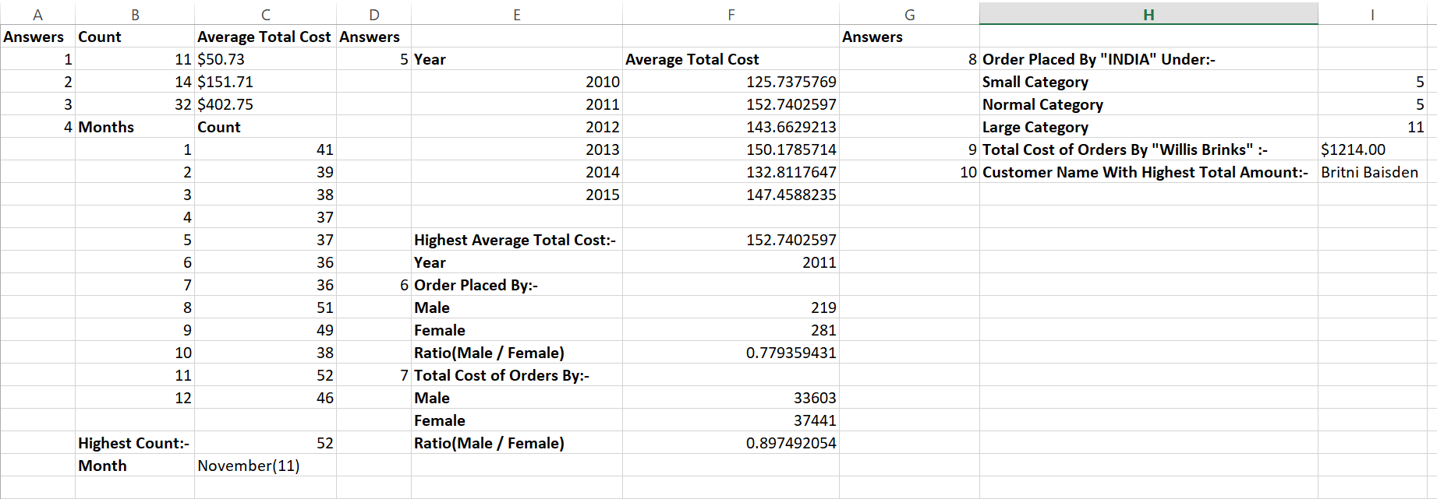

**Observation and Learnings:**

By Attempting this assignment we came to know the Various Functionalities of Microsoft Excel.